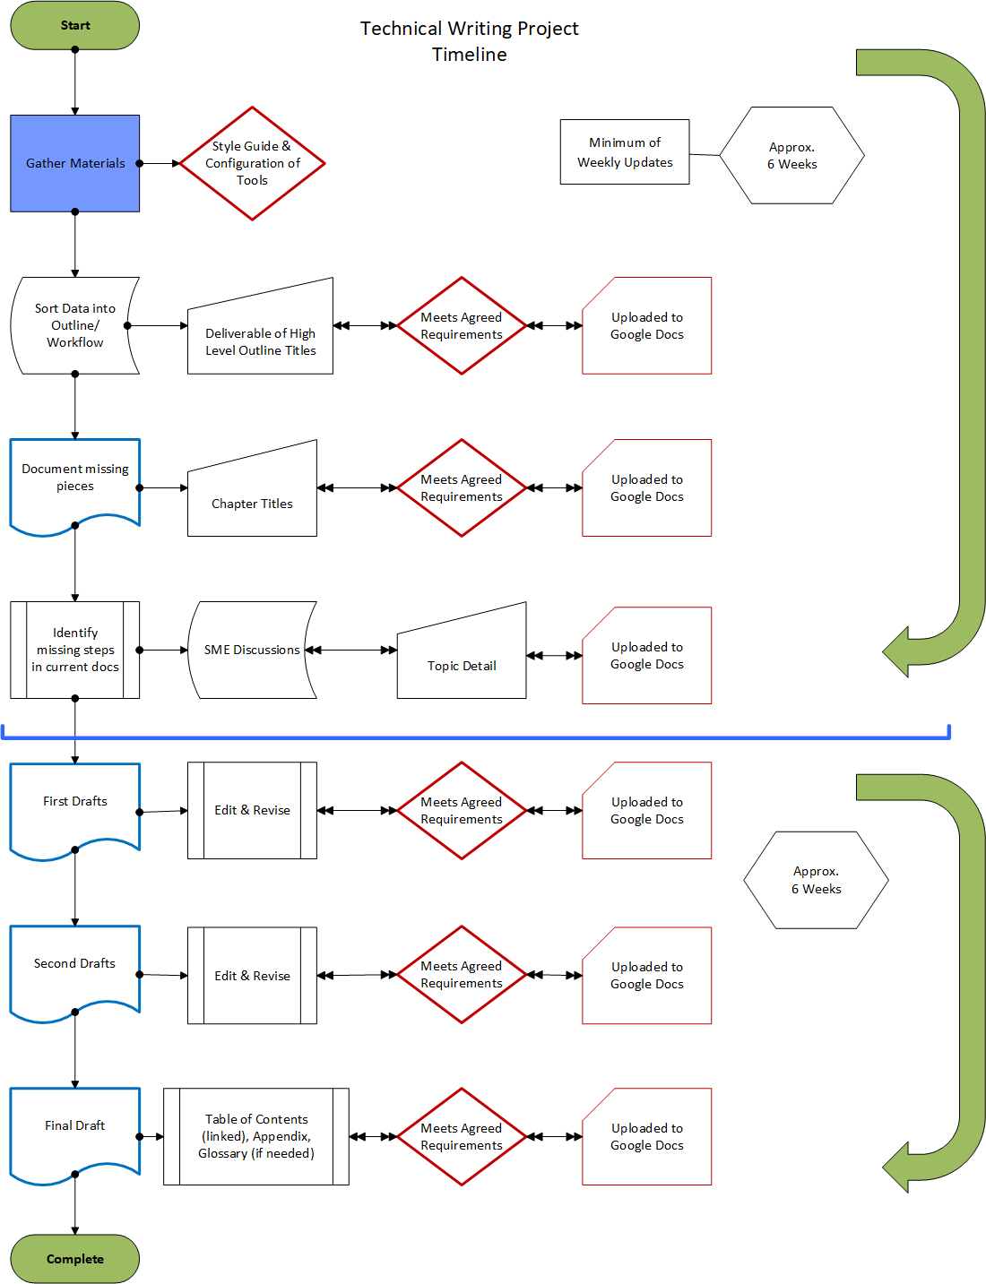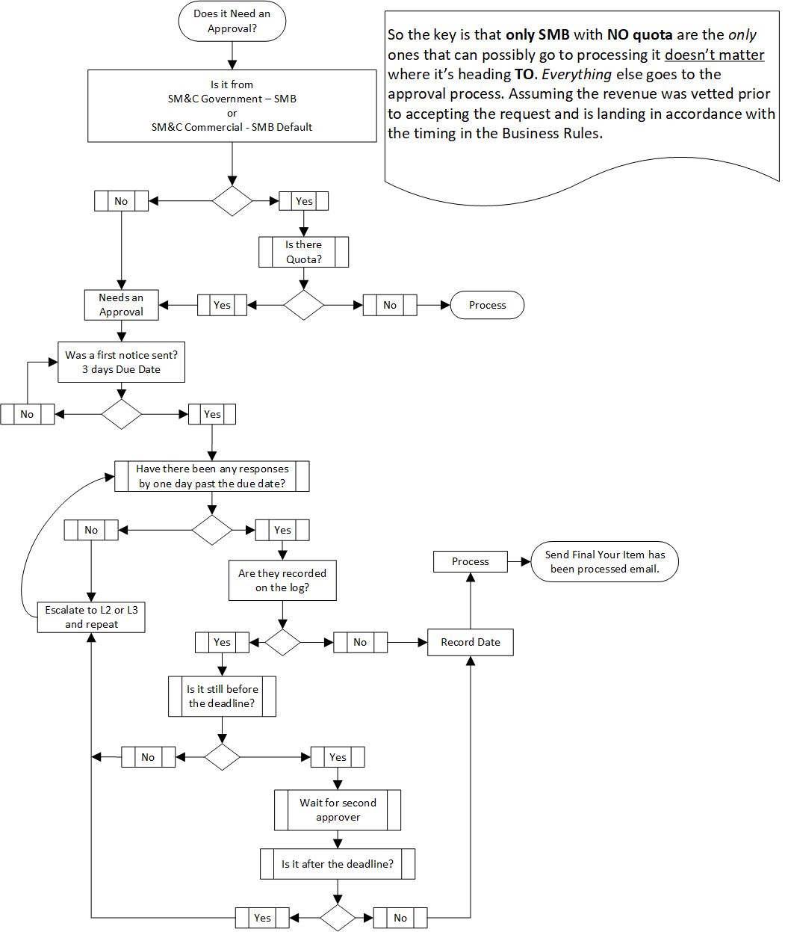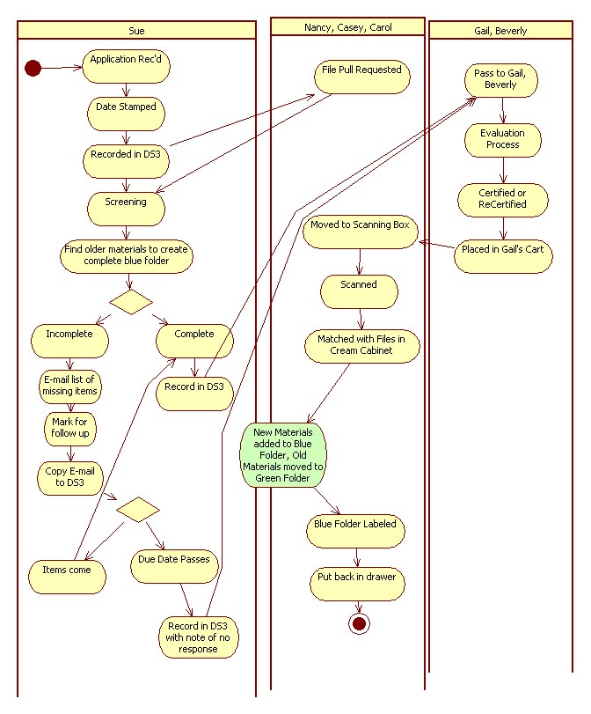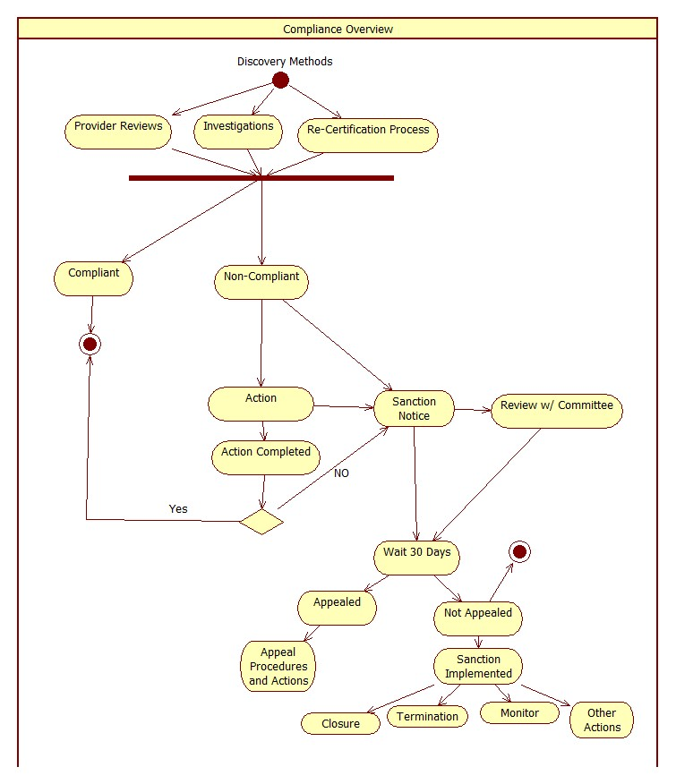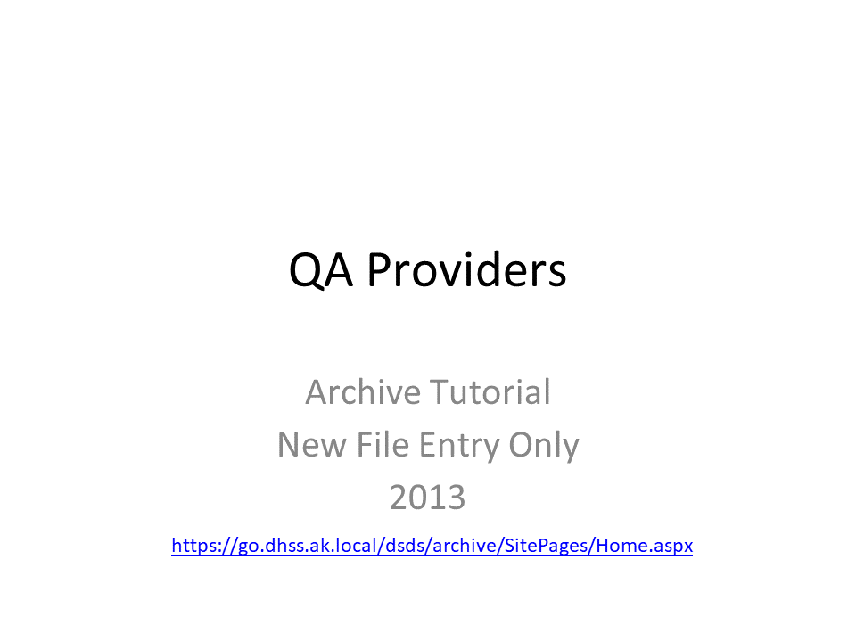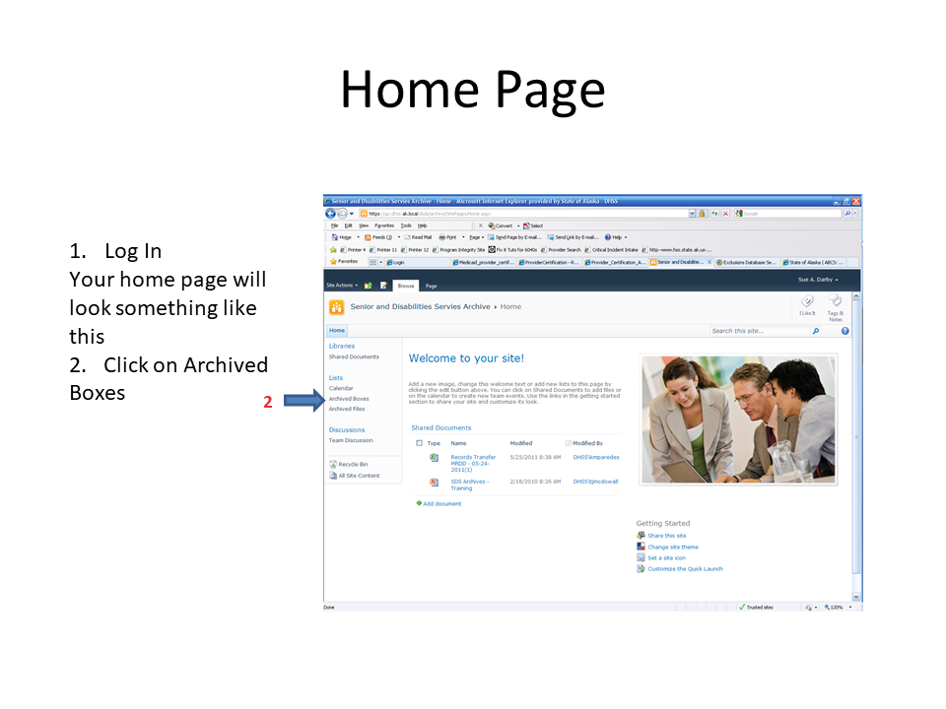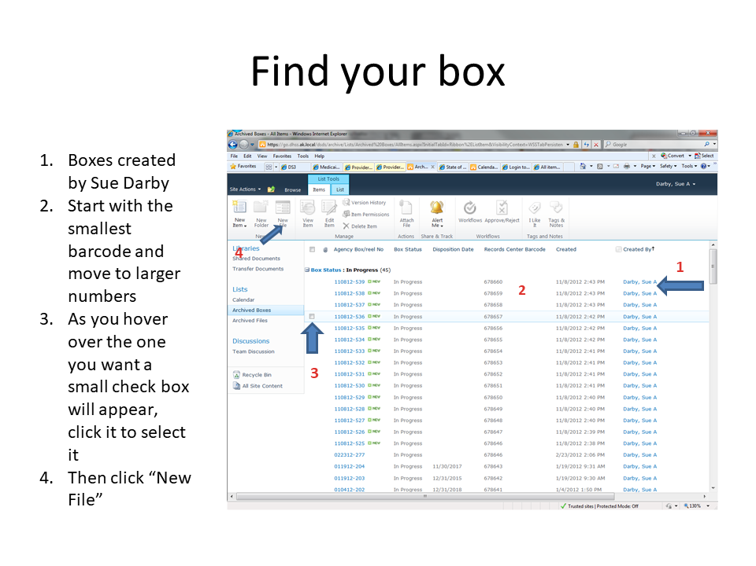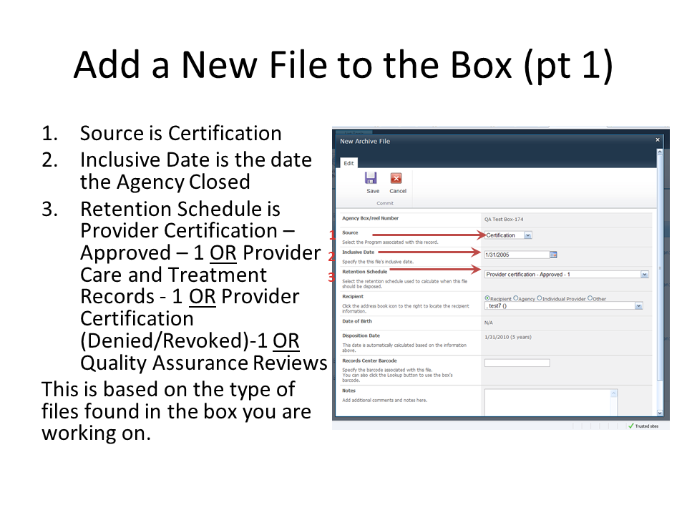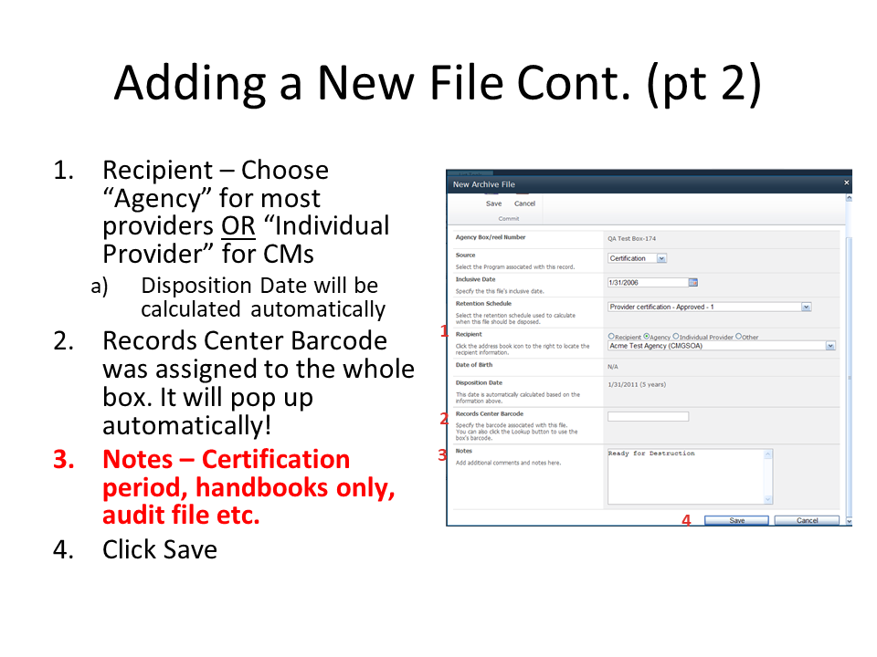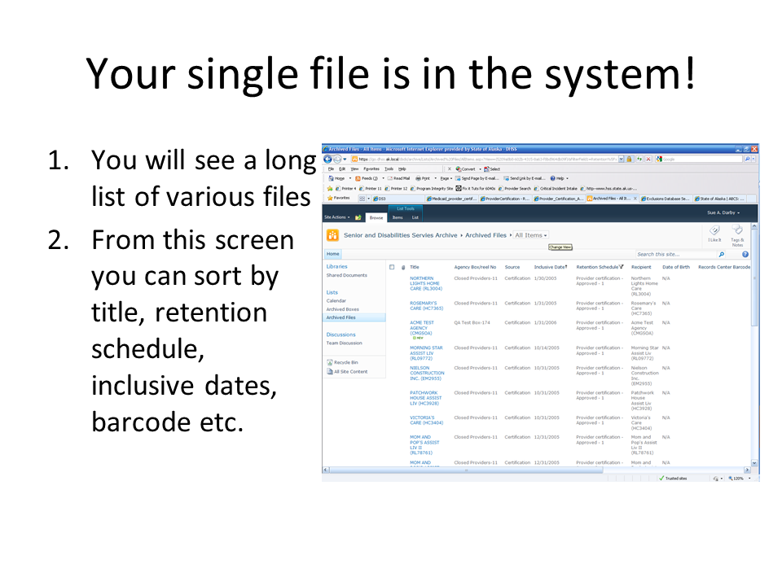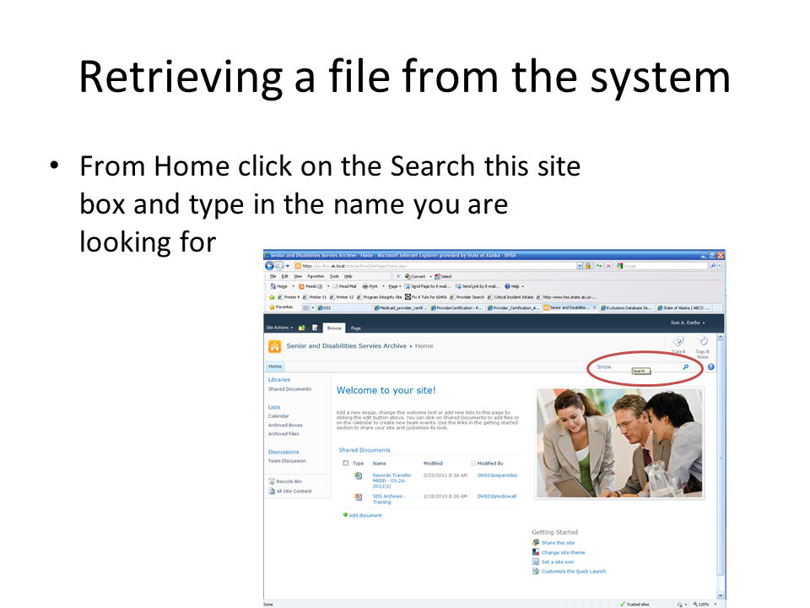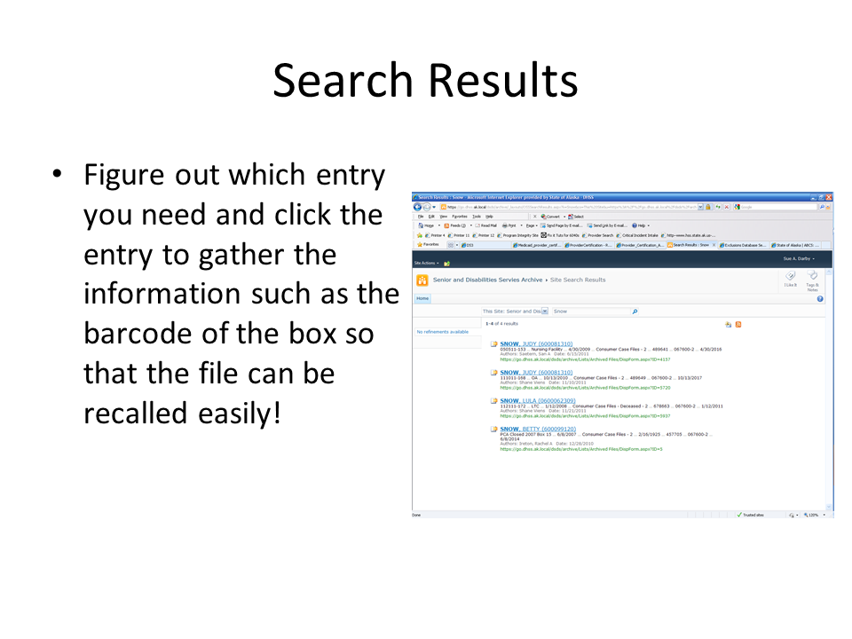

# Simple Show & Hide Checklists

# Purpose:

This is for a simple checklist where a group of items are based on a True or False statement.

# Process

1. Setup one column with **FALSE** on the row you want to have as the *section header*

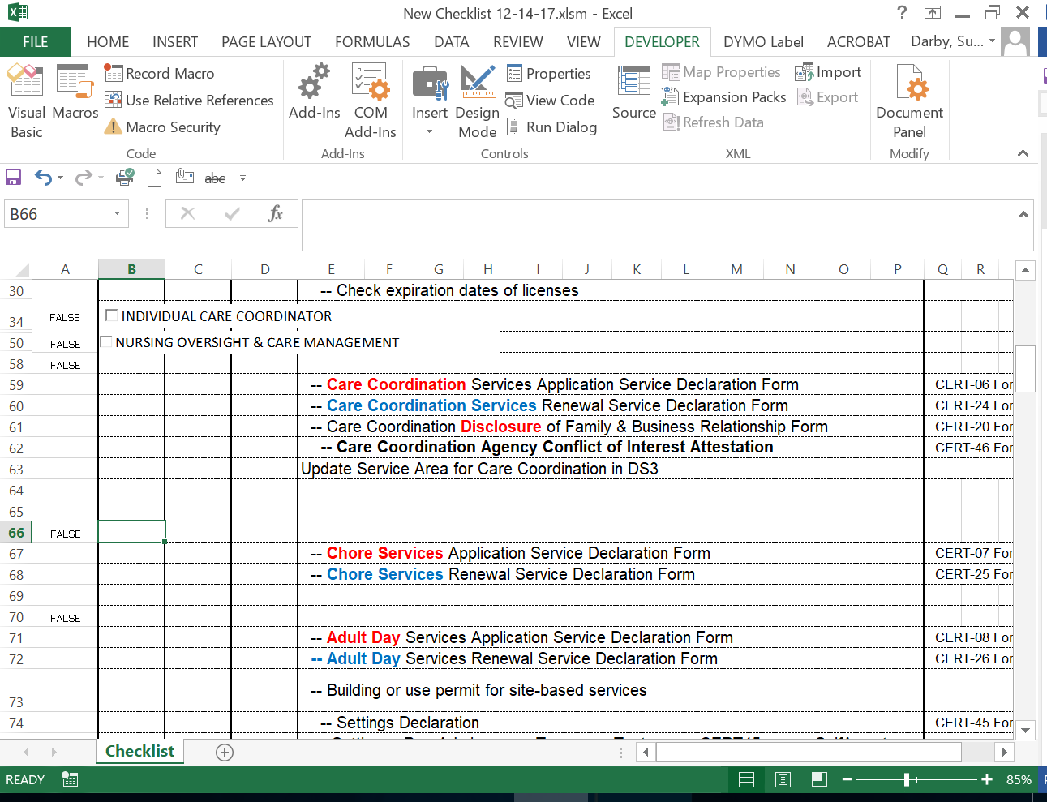

1. On the **Developer Toolbar** click **Design Mode**
2. Still on the **Developer Toolbar** click **Insert > Active X Control** and choose the checkbox

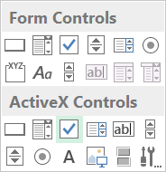

1. Draw your checkbox where desired

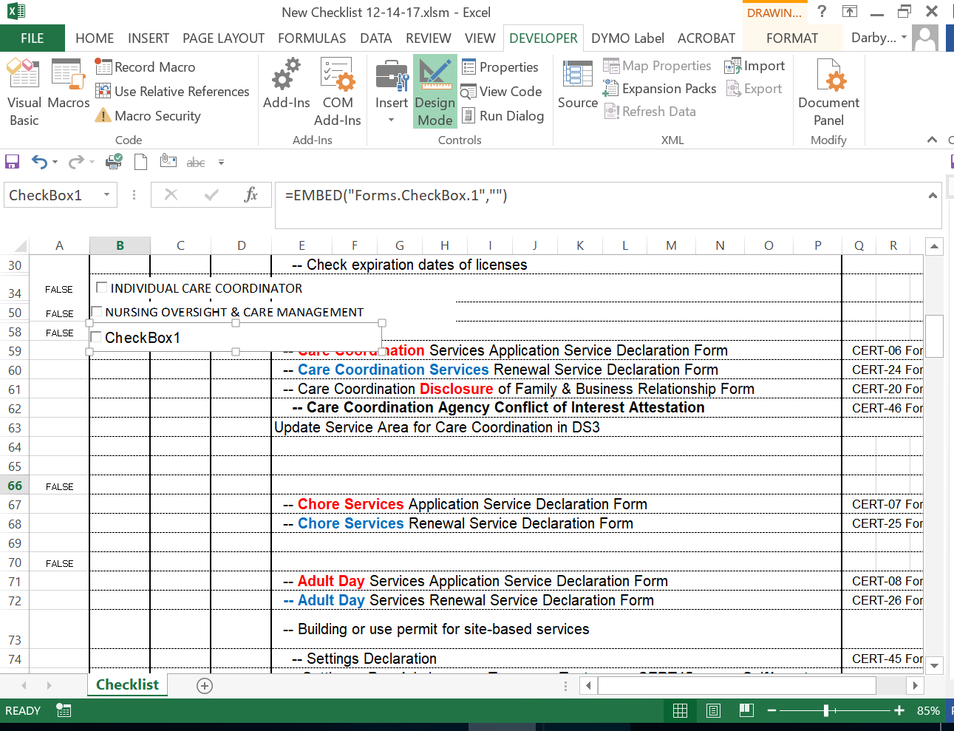

1. Right click on the checkbox and go to **Properties**

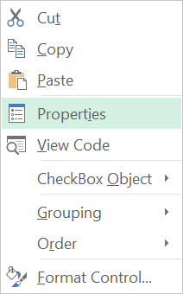

1. Name your checkbox and add your caption
2. In the linked cell add a $<column>$<row> absolute link, i.e., $A$58 this tells the macro where to look to perform the code you are about to program.

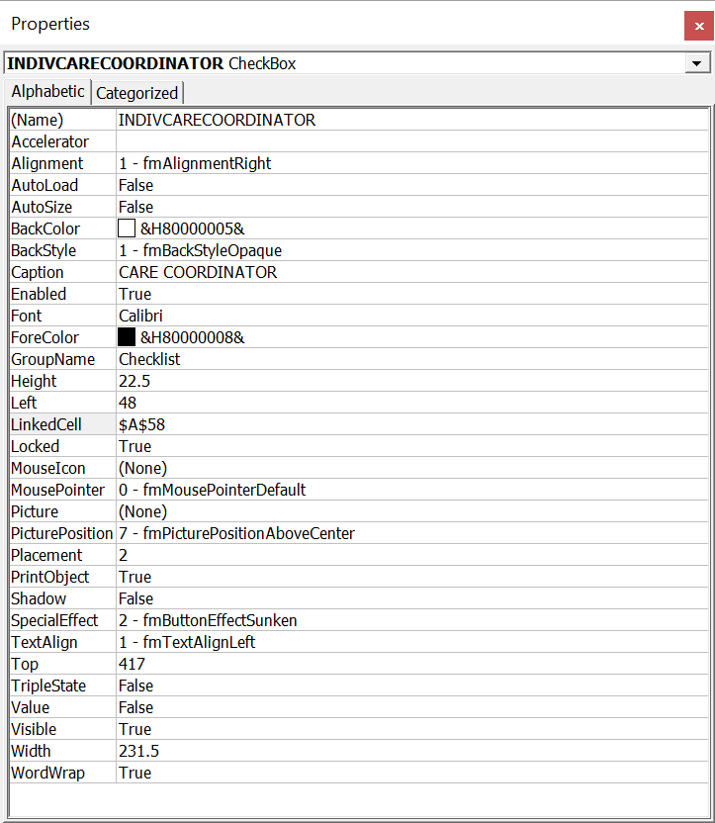

1. You can also adjust the font and font size, color etc. in this dialog so that it matches the rest of the project

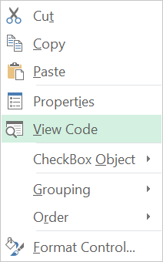

1. Right click on the checkbox and go to **View Code**

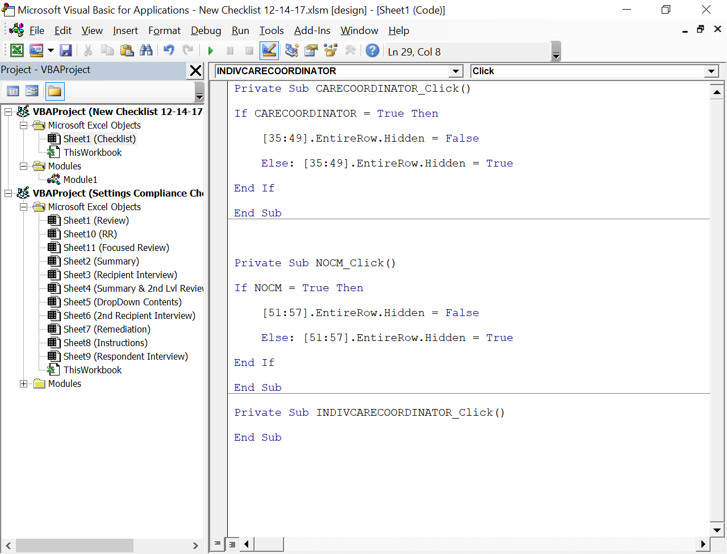

1. Based on the basic premise of **If → Then → Else** you can reuse the code to create the new function code

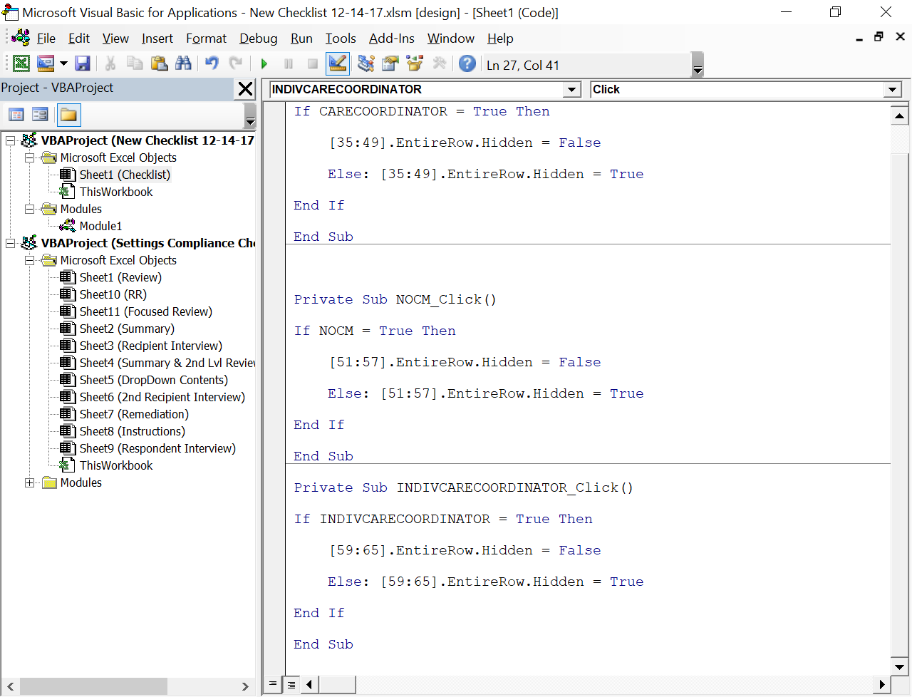

1. Use the first part of the **Private Sub** to fill in the **IF** portion of the statement
2. Change the numbers to show what lines you want to show and hide.

## Notes:

* There are extra lines between sections to easily add new items
* Adding a new line aka INSERTING a whole new row WILL require a recalculation of the show & hides of everything below! You can add new lines to the Common Requirements downward at will.